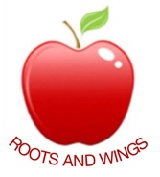

Governor Biog for Kirsten Hutton

Governor Type: Parent

Committees: Personnel (Chair), Health & Safety, Curriculum

Linked subjects: English & Modern Languages

Year of joining Governing Body: October 2016

Declaration of interests: None

About me:

I became a parent Governor in 2016. Both of my children attend the school.
I have worked in arts education for over 20 years, including being a secondary school teacher, and working in the theatre. As a freelance consultant I work with a variety of education settings and arts providers. At the moment I am working with a nearby local authority to support its schools and arts organisations to develop a cultural education partnership.

I am also a non-Executive Director of a London based arts organisation, and sit on an advisory group for a Watford based charity that aims to reduce loneliness in older people.

I enjoy being part of the Governor's team and being able to give some support to the school.

