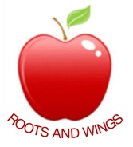

Governor Biog for Alison Hamper

Governor Type: Non–teaching Staff Governor

Committees: Finance & Healthy Schools

Linked subject: N/A

Year of commencement of term: 2014

Declaration of interests:
Member of Staff

About me:

I work at the school as the School Business Manager.

