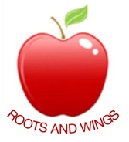

Governor Biog for Kate Curry

Governor Type: Non-teaching Staff Governor

Year of joining Governing Body: September 2008

Declaration of interests: Member of Staff

About me:

School SENDCo since 2010. Qualified - National SENCo Award (2012)

