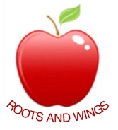

Governor Biog for Rebecca White

Governor Type:
Teaching Staff

Committees:
Curriculum

Linked subject:

Year of joining Governing Body:
September 2017

Declaration of interests:
Member of Staff

About me:
After spending some time working in the entertainment/retail industry I decided to study for a BSc in Psychology as this has always been a passion of mine. Upon graduating I worked for some time in a clinical setting within the NHS before starting my family.
Being able to watch my children grow and learn, gave me the impetus to train as a teacher. I have found teaching to be highly rewarding and am thrilled to be a part of the Governing Body so that Cheddington Combined can continue to provide high quality education to the children who attend.

