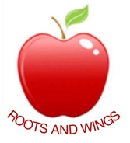

Governor Biog for Kathryn Tamlyn

Governor Type: Head Teacher

Committees: As the Head of the school I sit on all committees.

Year of joining Governing Body: Since appointment in January 2010

Declaration of interests: None

About me:

I am the Head Teacher of the school – a position I feel privileged to hold.

