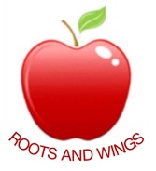

Governor Biog for Kirsti Lowery

Governor Type: Coop Governor

Committees: Health & Safety & Finance

Year of joining Governing Body: Sept 2017

Linked Subjects: Music, Art & Design Tech

Declaration of interests: Member of Staff

About me:

I was approached to become a Coop Governor at the school due to the volunteer work I have done in Slapton and having the advantage of being more of an ‘outsider’. I assist with family clubs and village fetes; bringing new ideas to the table and a different/fresh approach. Having a young son who has not started school yet - I feel I can be a good voice for the parents out there and will suggest things which others who have been a part of the group for a while would not necessarily think of.

Before becoming a TA at Cheddington, I worked as a part time Team Leader for a travel firm, and feel the skills I have in my job role will help to bring new or improved suggestions to the school and governing board.

